Section 2.4: Stacks and queues
Programming exercise
Write programs which add and delete items from a stack and a queue. Use the pseudocode algorithms shown in Section 2.4 of the text book to help you.
Adding and deleting items from a stack
- Set up this program as shown to the right  - Entering an item and pressing the Push button adds it to the array and adds it to the list box.  - Clicking Pop takes away the last item that was added. It deletes it from the array, and then re-displays the List Box with the item missing. The item removed is shown in a label.  - The number of items in the stack is shown at the bottom of the form.  - Extension: show the top of the stack pointer at the side of the list box | 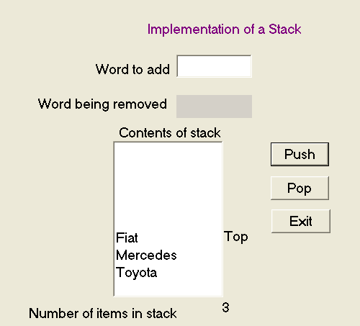
Adding and deleting items from a queue
There are two types of queue: a linear queue and a circular queue. In a linear queue, the items can be made to shuffle up as an item is deleted from the front of the queue. In a circular queue, the items do not shuffle up, but when the end of the queue is reached, the new items can go to free slots at the beginning of the queue. Start by implementing a simple linear queue with no shuffling. Then try to implement a circular queue as an extension task.
- Set up the program as shown to the right.  - Use a fixed length array to hold the items that are entered into the queue.  - The array can be shown in a list box. Adding an item adds it to the array, and increments the Rear pointer.  - Pressing Delete removes the first item that was added to the queue.  - Extension I: Show the Front and Back pointers  - Extension II: Implement a circular queue | 